create database concretepage;

use concretepage;

CREATE TABLE IF NOT EXISTS `parent_task_table` (

`parent_id` int(5) NOT NULL AUTO_INCREMENT,

`parent_task` varchar(100) ,

PRIMARY KEY (`parent_id`)

);

CREATE TABLE IF NOT EXISTS `task_table` (

`id` int(5) NOT NULL AUTO_INCREMENT,

`task_id` int(5) ,

`parent_id` int(5),

`task` varchar(100) ,

`start_date` varchar(100) ,

`end_date` varchar(100) ,

`priority` int(5),

PRIMARY KEY (`id`),

FOREIGN KEY (`parent_id`) REFERENCES parent_task_table(`parent_id`)

);

select * from parent_task_table;

SELECT * from task_table;s

Validation via Postman

<http://localhost:8080/task/addTask>

Method : POST

JSON BODY

{

"parentTaskid": 2,

"ptaskName": "1",

"task_id": 0,

"task": "t1",

"start_date": "1/1/2020",

"end_date": "1/1/2019",

"priority": 1

}

<http://localhost:8080/task/getAllTasks>

method: GET

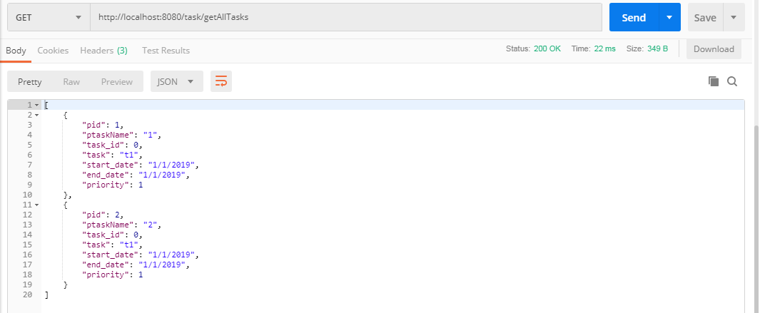

<http://localhost:8080/task/task/1>

method: GET

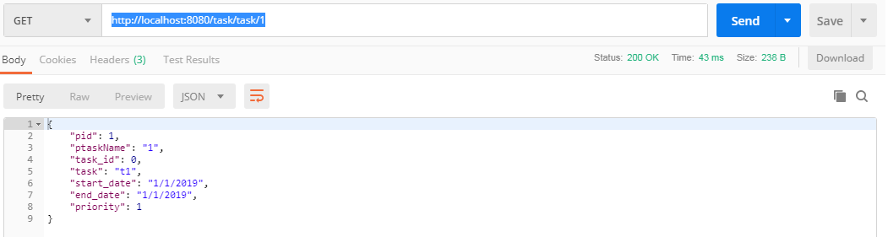

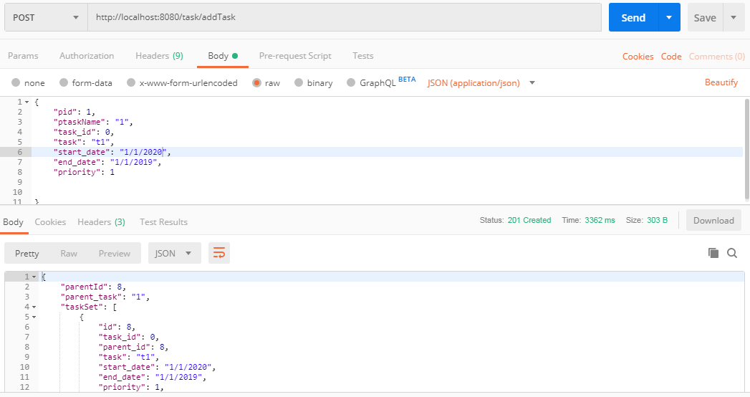

{

"parent_task":"test",

"taskSet":

[{

"task":"t1",

"tasak_id": 10,

"start_date":"1/1/2019",

"end_date":"1/1/2019",

"priority":1

}]

}